**“Skipper Otto” Dafne's Kelp Lasagna Recipe**

Kelper extraordinaire, Dafne Romero. suggests using kelp blades as a substitute for lasagna noodles, adding them to omelettes, wrapping a fish fillet, or tossing straight in your favourite coleslaw recipe! These kelp blades are a great replacement for spinach or kale (can you say kelp chips?).

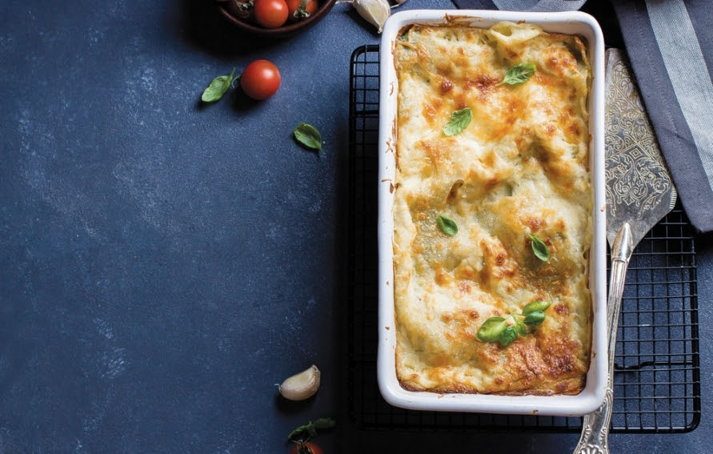

Preparation - Preheat the oven to 375F.

1 package giant kelp noodles, approximately 8 large pieces  
1 to 2 zucchinis, chopped  
1 bunch of spinach or kale, washed and chopped  
4 stalks of thick asparagus, washed and chopped   
2 stalks of garlic scapes, chopped, or 2 cloves, minced  
1 pound of ground beef  
1 can (28 ounce) of crushed tomatoes  
1 can (6 ounce of tomato paste1 can (61/2 ounce) of tomato sauce  
1/2 teaspoon each of herbs, such as dried oregano, basil, thyme and chilis  
3/4 pound medium cheddar, grated   
3/4 pound old cheddar, sliced   
3/4 cup Pecorino Romano cheese, grated

In a Dutch oven, cook the ground beef over medium-high heat. When the beef starts to lose its pink colour, add the spinach or kale, garlic and asparagus and cook over medium heat for another 5 minutes and set aside.

Place a pot over medium heat and add crushed tomatoes, tomato paste and tomato sauce. Season with herbs and simmer with the lid on. After 30 minutes, incorporate the meat and vegetables and cook for another 15 minutes, then set aside.

Bring a large pot of water to a boil. Cook the kelp in boiling water for 5 to 7 minutes. Drain and rinse with cold water.

In a mixing bowl, combine grated cheeses.

To assemble, spread 11/2cups of the sauce in the bottom of a 9x13-inch baking dish. Arrange 4 giant kelp noodles lengthwise over meat sauce. Spread with one half of the cheese mixture. Top with a third of old cheddar cheese slices. Spoon 11/2cups meat sauce over it and sprinkle with 1/4cup umami-rich Pecorino Romano. Repeat layers and top with remaining cheeses. Cover with foil. To prevent sticking, either spray foil with cooking spray or make sure the foil does not touch the cheese.

Bake for 25 minutes.  Remove Foil. Let sit for 15 min before serving.

Remove foil. Let it sit for 15 to 20 minutes before serving.