HOW DO I PLAY: DETAILED INSTRUCTIONS

Virtual Inshore Regatta

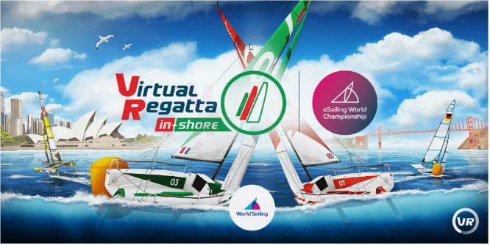

With a Computer:

Follow the link to: https://www.virtualregatta.com/en/inshore-game/

Create a Virtual Regatta account

With an iPad or iPhone or Android Device:

APP Store and Search: Virtual Regatta Inshore
Install the app and create an account

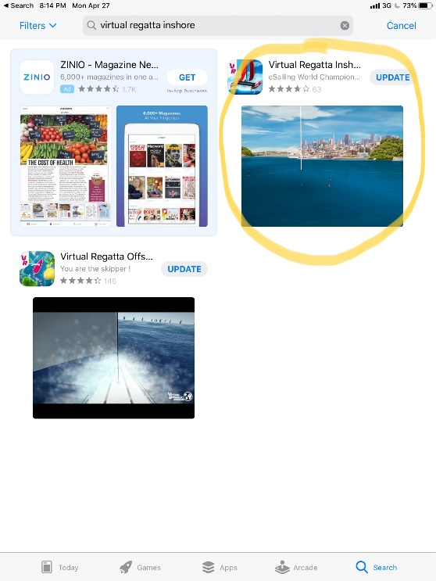
How to Join IYC Regatta:

Select Custom Race:

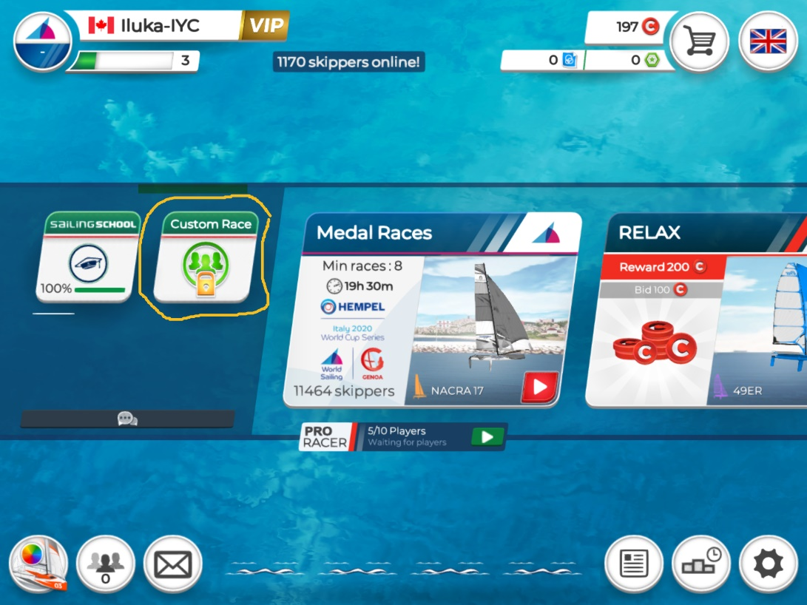

Select the Lock Box:
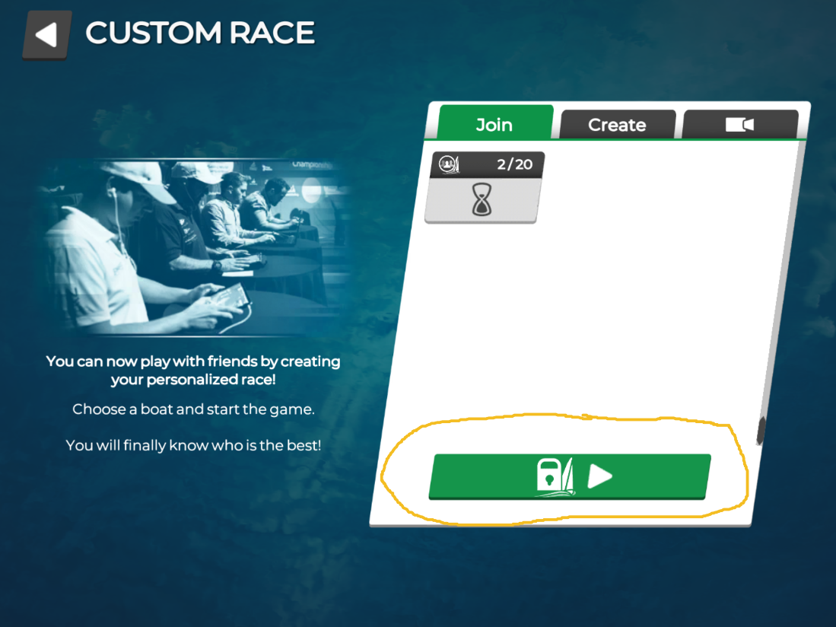

You will get the following PopUP: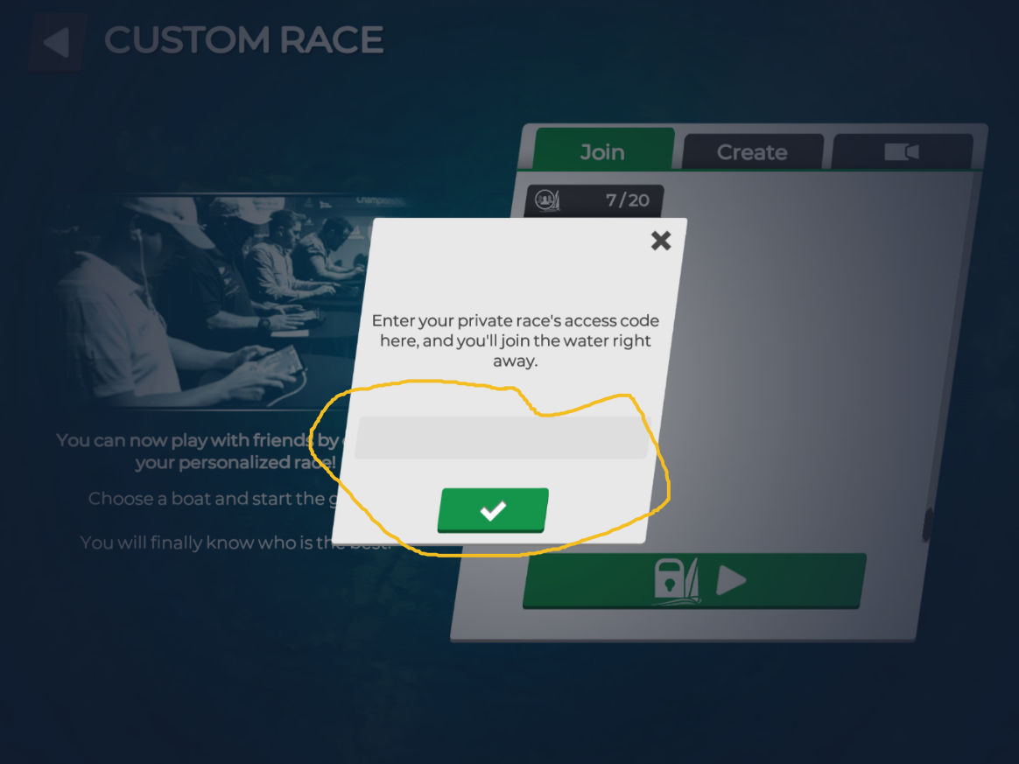

Enter the Given Race Code (may change):

